Test Cases:

**Insertion:**

1. Insertion of a positive element:

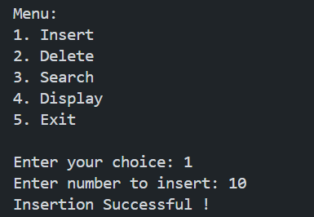

1. Insertion of negative element:

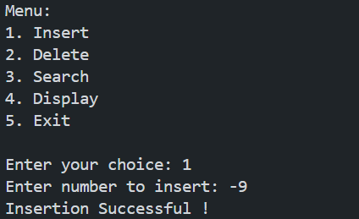

**Deletion:**

1.Deletion of element that exist in B-Tree:

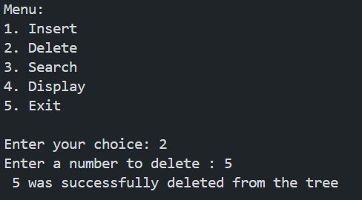

**Searching:**

1.Searching existing element

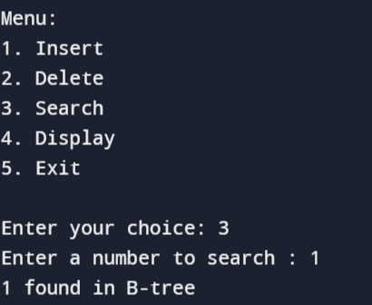

1.Displaying a filled B-Tree

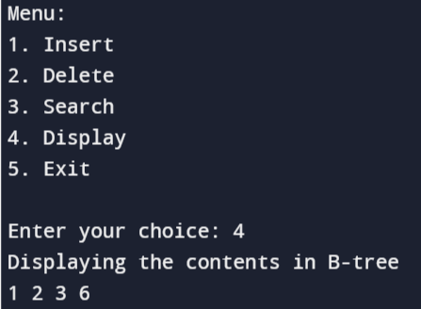

Handling Error Cases:

1.Attemp to give invalid choice and character in menu driven program:

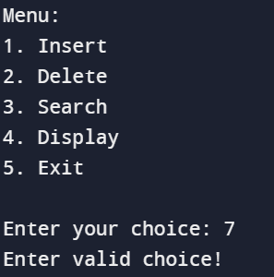

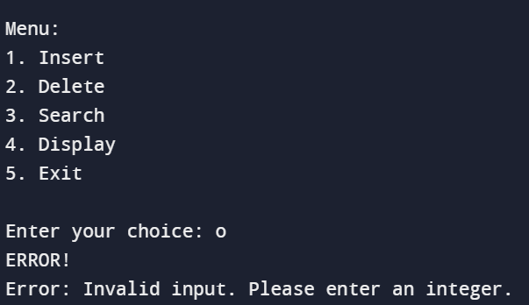

2.Attempt to give order of 1 or lesser and a character

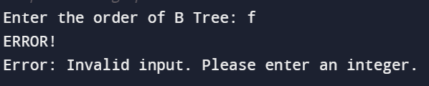

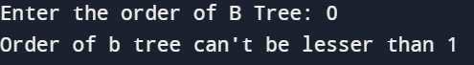

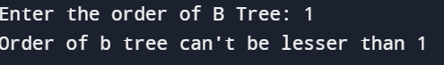

3.Attempt to delete and search non existing element:

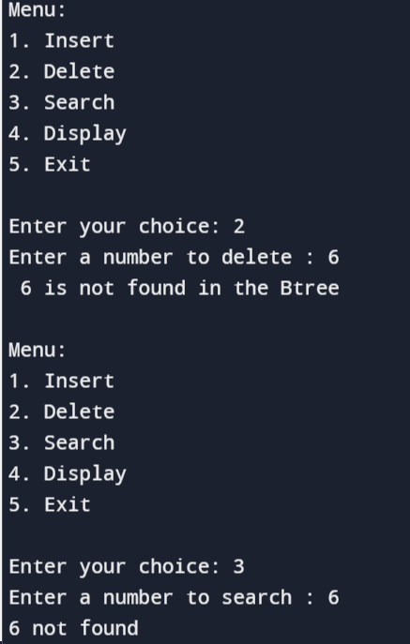

4.Attempt to delete and search empty B-Tree

